A1382-ME-**Gobekli Tepe-Statuette-**9130–8800 BCE

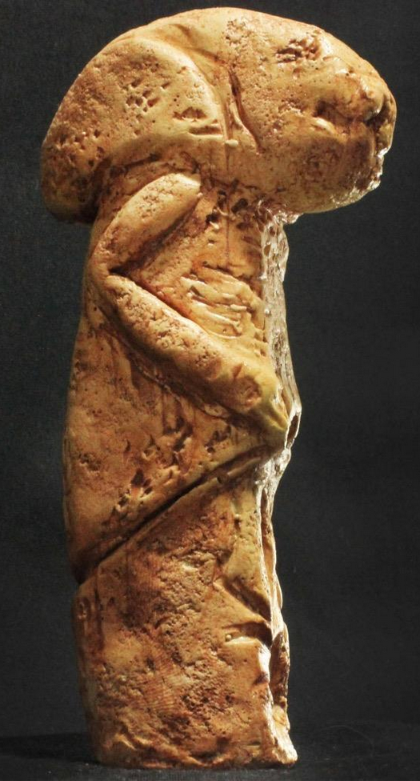 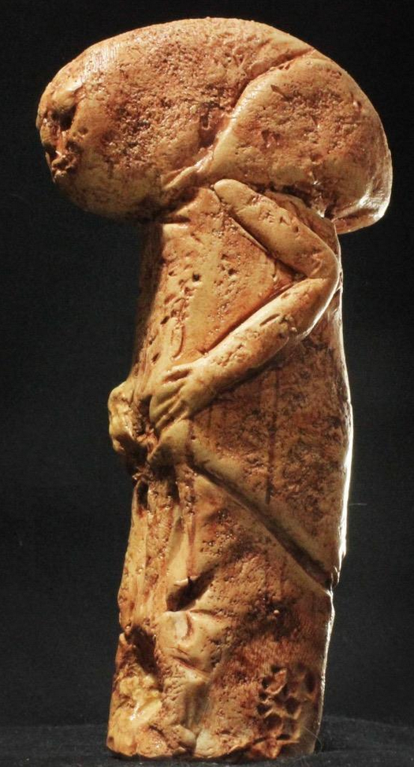 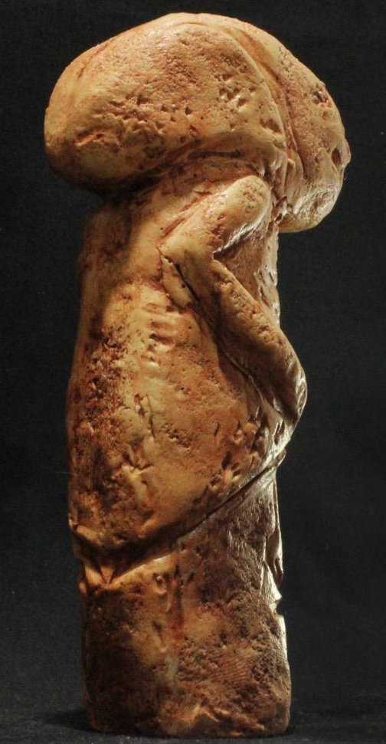 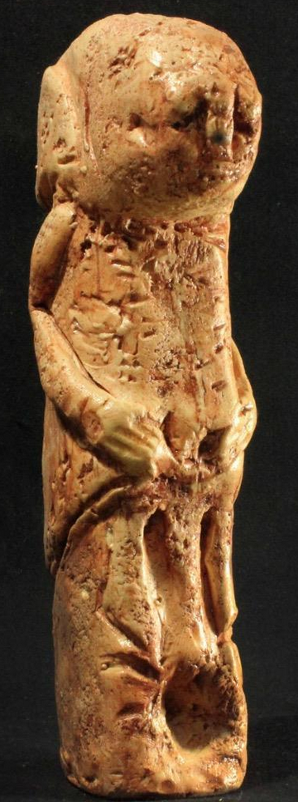

Göbekli Tepe figurine from the archaeological site in the Southeastern Anatolia Region of Turkey, approximately 12 km (7 mi) northeast of the city of [Şanlıurfa](https://en.wikipedia.org/wiki/%C5%9Eanl%C4%B1urfa). The [tell](https://en.wikipedia.org/wiki/Tell_(archaeology)) has a height of 15 m (49 ft) and is about 300 m (980 ft) in diameter.[[3]](https://en.wikipedia.org/wiki/G%C3%B6bekli_Tepe#cite_note-3) It is approximately 760 m (2,490 ft) above sea level. Dated to 9130–8800 BCE it predates Stonehenge and ancient Sumeria by around 6,000 years. The Gobekli Tepe temple is one of the oldest archaeological excavation sites in the world and the source of some of the strangest statues and artefacts such as this statuette of a figure in priest-like garments with a strangely elongated head.

The tell includes two phases of use believed to be of a social or ritual nature dating back to the 10th–8th millennium BCE. During the first phase, belonging to the Pre-Pottery Neolithic A (PPNA), circles of massive T-shaped stone pillars were erected – the world's oldest known [megaliths](https://en.wikipedia.org/wiki/Megalith).[[4]](https://en.wikipedia.org/wiki/G%C3%B6bekli_Tepe#cite_note-4) More than 200 pillars in about 20 circles are currently known through geophysical surveys. Each pillar has a height of up to 6 m (20 ft) and weighs up to 20 tons. They are fitted into sockets that were hewn out of the bedrock.[[5]](https://en.wikipedia.org/wiki/G%C3%B6bekli_Tepe#cite_note-5) In the second phase, belonging to the [Pre-Pottery Neolithic B](https://en.wikipedia.org/wiki/Pre-Pottery_Neolithic_B) (PPNB), the erected pillars are smaller and stood in rectangular rooms with floors of polished lime. The site was abandoned after the PPNB. Younger structures date to classical times.

The details of the structure's function remain a mystery. It was excavated by a German archaeological team under the direction of Klaus Schmidt from 1996 until his death in 2014. Schmidt believed that the site was a sanctuary where people from a wide region periodically congregated, not a settlement.

**Contents**

* [1 Discovery](https://en.wikipedia.org/wiki/G%C3%B6bekli_Tepe#Discovery)
* [2 Dating](https://en.wikipedia.org/wiki/G%C3%B6bekli_Tepe#Dating)
* [3 Complex](https://en.wikipedia.org/wiki/G%C3%B6bekli_Tepe#Complex)
  + [3.1 Plateau](https://en.wikipedia.org/wiki/G%C3%B6bekli_Tepe#Plateau)
  + [3.2 Layer III](https://en.wikipedia.org/wiki/G%C3%B6bekli_Tepe#Layer_III)
  + [3.3 Layer II](https://en.wikipedia.org/wiki/G%C3%B6bekli_Tepe#Layer_II)
  + [3.4 Layer I](https://en.wikipedia.org/wiki/G%C3%B6bekli_Tepe#Layer_I)
* [4 Chronological context](https://en.wikipedia.org/wiki/G%C3%B6bekli_Tepe#Chronological_context)
* [5 Interpretation](https://en.wikipedia.org/wiki/G%C3%B6bekli_Tepe#Interpretation)
* [6 Importance](https://en.wikipedia.org/wiki/G%C3%B6bekli_Tepe#Importance)
* [7 Conservation](https://en.wikipedia.org/wiki/G%C3%B6bekli_Tepe#Conservation)
* [8 See also](https://en.wikipedia.org/wiki/G%C3%B6bekli_Tepe#See_also)
* [9 Notes](https://en.wikipedia.org/wiki/G%C3%B6bekli_Tepe#Notes)
* [10 References](https://en.wikipedia.org/wiki/G%C3%B6bekli_Tepe#References)
* [11 External links](https://en.wikipedia.org/wiki/G%C3%B6bekli_Tepe#External_links)
  + [11.1 Articles](https://en.wikipedia.org/wiki/G%C3%B6bekli_Tepe#Articles)
  + [11.2 Photographs](https://en.wikipedia.org/wiki/G%C3%B6bekli_Tepe#Photographs)
  + [11.3 Videos](https://en.wikipedia.org/wiki/G%C3%B6bekli_Tepe#Videos)

**Discovery**

[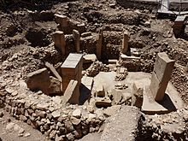](https://en.wikipedia.org/wiki/File:G%C3%B6bekli_Tepe_site_(1).JPG)

Göbekli Tepe site (1)

The site was first noted in a [survey](https://en.wikipedia.org/wiki/Archaeological_field_survey) conducted by [Istanbul University](https://en.wikipedia.org/wiki/Istanbul_University) and the [University of Chicago](https://en.wikipedia.org/wiki/University_of_Chicago) in 1963.[[6]](https://en.wikipedia.org/wiki/G%C3%B6bekli_Tepe#cite_note-6) American archaeologist Peter Benedict identified [lithics](https://en.wikipedia.org/wiki/Stone_tool) collected from the surface of the site as belonging to the [Aceramic Neolithic](https://en.wikipedia.org/wiki/Aceramic_Neolithic),[[7]](https://en.wikipedia.org/wiki/G%C3%B6bekli_Tepe#cite_note-7) but mistook the stone slabs (the upper parts of the T-shaped pillars) for grave markers, postulating that the prehistoric phase was overlain by a [Byzantine](https://en.wikipedia.org/wiki/Byzantine) cemetery.[[8]](https://en.wikipedia.org/wiki/G%C3%B6bekli_Tepe#cite_note-8)[[9]](https://en.wikipedia.org/wiki/G%C3%B6bekli_Tepe#cite_note-9) The hill had long been under agricultural cultivation, and generations of local inhabitants had frequently moved rocks and placed them in clearance piles, which may have disturbed the upper layers of the site. At some point attempts had been made to break up some of the pillars, presumably by farmers who mistook them for ordinary large rocks.[[10]](https://en.wikipedia.org/wiki/G%C3%B6bekli_Tepe#cite_note-Smithsonian-10)

In 1994, [Klaus Schmidt](https://en.wikipedia.org/wiki/Klaus_Schmidt_(archaeologist)) of the [German Archaeological Institute](https://en.wikipedia.org/wiki/German_Archaeological_Institute), who had previously been working at [Nevalı Çori](https://en.wikipedia.org/wiki/Neval%C4%B1_%C3%87ori), was looking for another site to excavate. He reviewed the archaeological literature on the surrounding area, found the 1963 Chicago researchers’ brief description of Göbekli Tepe, and decided to reexamine the site. Having found similar structures at Nevalı Çori, he recognized the possibility that the rocks and slabs were prehistoric. The following year, he began excavating there in collaboration with the [Şanlıurfa Museum](https://en.wikipedia.org/wiki/%C5%9Eanl%C4%B1urfa_Museum), and soon unearthed the first of the huge T-shaped pillars.[[10]](https://en.wikipedia.org/wiki/G%C3%B6bekli_Tepe#cite_note-Smithsonian-10)

**Dating**

[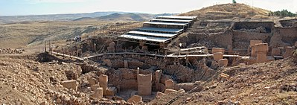](https://en.wikipedia.org/wiki/File:G%C3%B6bekli_Tepe.jpg)

View of site and excavation

The imposing [stratigraphy](https://en.wikipedia.org/wiki/Stratigraphy) of Göbekli Tepe attests to many centuries of activity, beginning at least as early as the [Epipaleolithic](https://en.wikipedia.org/wiki/Epipaleolithic) period. Structures identified with the succeeding period, [Pre-Pottery Neolithic A](https://en.wikipedia.org/wiki/Pre-Pottery_Neolithic_A) (PPNA), have been dated to the 10th millennium BCE. Remains of smaller buildings identified as [Pre-Pottery Neolithic B](https://en.wikipedia.org/wiki/Pre-Pottery_Neolithic_B) (PPNB) and dating from the 9th millennium BCE have also been unearthed.

A number of [radiocarbon dates](https://en.wikipedia.org/wiki/Radiocarbon_dating) have been published:

|  |  |  |
| --- | --- | --- |
| **Lab-Number** | **Context** | **cal BCE** |
| Ua-19561 | enclosure C | 7560–7370 |
| Ua-19562 | enclosure B | 8280–7970 |
| Hd-20025 | Layer III | 9110–8620 |
| Hd-20036 | Layer III | 9130–8800 |

The Hd samples are from [charcoal](https://en.wikipedia.org/wiki/Charcoal) in the fill of the lowest levels of the site and would date the end of the active phase of occupation of Level III - the actual structures will be older. The Ua samples come from [pedogenic](https://en.wikipedia.org/wiki/Pedogenesis) [carbonate](https://en.wikipedia.org/wiki/Carbonate) coatings on pillars and only indicate the time after the site was abandoned—the [*terminus ante quem*](https://en.wikipedia.org/wiki/Terminus_ante_quem).[[11]](https://en.wikipedia.org/wiki/G%C3%B6bekli_Tepe#cite_note-11)

**Complex**

Göbekli Tepe is on a flat and barren [plateau](https://en.wikipedia.org/wiki/Plateau), with buildings fanning in all directions. In the north, the plateau is connected to a neighbouring mountain range by a narrow [promontory](https://en.wikipedia.org/wiki/Promontory). In all other directions, the ridge descends steeply into slopes and steep cliffs.[[12]](https://en.wikipedia.org/wiki/G%C3%B6bekli_Tepe#cite_note-12) On top of the ridge there is considerable evidence of human impact, in addition to the actual tell. Excavations have taken place at the southern slope of the tell, south and west of a [mulberry](https://en.wikipedia.org/wiki/Mulberry) that marks an Islamic pilgrimage,[[13]](https://en.wikipedia.org/wiki/G%C3%B6bekli_Tepe#cite_note-13) but archaeological finds come from the entire plateau. The team has also found many remains of tools.

**Plateau**

[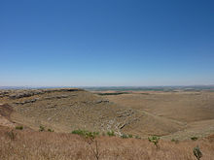](https://en.wikipedia.org/wiki/File:G%C3%B6bekli_Tepe_surrounding_area.JPG)

Göbekli Tepe surrounding area

[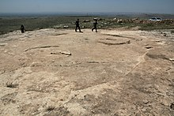](https://en.wikipedia.org/wiki/File:G%C3%B6bekli2012-20.jpg)

Complex E

The plateau has been transformed by [erosion](https://en.wikipedia.org/wiki/Erosion) and by [quarrying](https://en.wikipedia.org/wiki/Quarry), which took place not only in the Neolithic, but also in classical times. There are four 10-metre-long (33 ft) and 20-centimetre-wide (7.9 in) channels on the southern part of the plateau, interpreted as the remains of an ancient quarry from which rectangular blocks were taken. These are possibly related to a square building in the neighbourhood, of which only the foundation is preserved. Presumably, this is the remains of a Roman [watchtower](https://en.wikipedia.org/wiki/Watchtower) which belonged to the [Limes Arabicus](https://en.wikipedia.org/wiki/Limes_Arabicus). However, this is not known with certainty.[[14]](https://en.wikipedia.org/wiki/G%C3%B6bekli_Tepe#cite_note-Schmitt_2006,_p._105-14)

Most structures on the plateau seem to be the result of Neolithic quarrying, with the quarries being used as sources for the huge, monolithic architectural elements. Their profiles were pecked into the rock, with the detached blocks then levered out of the rock bank.[[14]](https://en.wikipedia.org/wiki/G%C3%B6bekli_Tepe#cite_note-Schmitt_2006,_p._105-14) Several quarries where round workpieces had been produced were identified. Their status as quarries was confirmed by the find of a 3-by-3-metre piece at the southeastern slope of the plateau. Unequivocally Neolithic are three T-shaped pillars that have not been levered out of the bedrock. The biggest of them lies on the northern plateau. It has a length of 7 m (23 ft) and its head has a width of 3 m (10 ft). Its weight may be around 50 tons. The two other unfinished pillars lie on the southern Plateau.

At the western edge of the hill, a lion-like figure was found. In this area, [flint](https://en.wikipedia.org/wiki/Flint) and limestone fragments occur more frequently. It was therefore suggested that this could have been some kind of sculpture workshop.[[15]](https://en.wikipedia.org/wiki/G%C3%B6bekli_Tepe#cite_note-15) It is unclear, on the other hand, how to classify three [phallic](https://en.wikipedia.org/wiki/Phallus) depictions from the surface of the southern plateau. They are near the quarries from classical times, making their dating difficult.[[16]](https://en.wikipedia.org/wiki/G%C3%B6bekli_Tepe#cite_note-Schmidtp111-16)

Apart from the tell, there is an incised platform with two sockets that could have held pillars, and a surrounding flat bench. This platform corresponds to the complexes from Layer III at the actual tell. Continuing the naming pattern, it is called "complex E." Owing to its similarity to the cult-buildings at [Nevalı Çori](https://en.wikipedia.org/wiki/Neval%C4%B1_%C3%87ori) it has also been called "Temple of the Rock." Its floor has been carefully hewn out of the bedrock and smoothed, reminiscent of the [terrazzo](https://en.wikipedia.org/wiki/Terrazzo) floors of the younger complexes at Göbekli Tepe. Immediately northwest of this area are two cistern-like pits, believed to be part of complex E. One of these pits has a table-high pin as well as a staircase with five steps.[[17]](https://en.wikipedia.org/wiki/G%C3%B6bekli_Tepe#cite_note-17)

At the western [escarpment](https://en.wikipedia.org/wiki/Escarpment), a small cave has been discovered in which a small [relief](https://en.wikipedia.org/wiki/Relief) depicting a bovine was found. It is the only relief found in this cave.[[16]](https://en.wikipedia.org/wiki/G%C3%B6bekli_Tepe#cite_note-Schmidtp111-16)

**Layer III**

[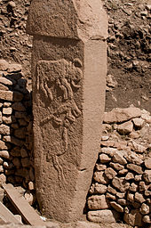](https://en.wikipedia.org/wiki/File:Gobekli_Tepe_2.jpg)

Pillar 2 from Enclosure A (Layer III) with [low reliefs](https://en.wikipedia.org/wiki/Low_relief) of what are believed to be a [bull](https://en.wikipedia.org/wiki/Bull), [fox](https://en.wikipedia.org/wiki/Fox), and [crane](https://en.wikipedia.org/wiki/Crane_(bird)).

At this early stage of the site's history, circular compounds or [*temene*](https://en.wikipedia.org/wiki/Temenos) first appear. They range from 10 to 30 metres in diameter. Their most notable feature is the presence of T-shaped limestone pillars evenly set within thick interior walls composed of unworked stone. Four such circular structures have been unearthed so far. Geophysical surveys indicate that there are 16 more, enclosing up to eight pillars each, amounting to nearly 200 pillars in all. The slabs were transported from bedrock pits located approximately 100 metres (330 ft) from the hilltop, with workers using flint points to cut through the limestone bedrock.[[18]](https://en.wikipedia.org/wiki/G%C3%B6bekli_Tepe#cite_note-18)

[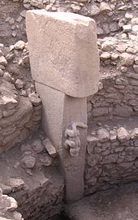](https://en.wikipedia.org/wiki/File:GobeklitepeHeykel.jpg)

Pillar 27 from Enclosure C (Layer III) with the sculpture of a predatory animal

[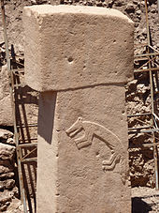](https://en.wikipedia.org/wiki/File:G%C3%B6bekli_Tepe_Pillar.JPG)

Pillar with the sculpture of a fox

Two taller pillars stand facing one another at the centre of each circle. Whether the circles were provided with a roof is uncertain. Stone benches designed for sitting are found in the interior.[[19]](https://en.wikipedia.org/wiki/G%C3%B6bekli_Tepe#cite_note-19) Many of the pillars are decorated with [abstract](https://en.wikipedia.org/wiki/Abstract_art), enigmatic [pictograms](https://en.wikipedia.org/wiki/Pictogram) and [carved](https://en.wikipedia.org/wiki/Sculpture) animal reliefs. The pictograms may represent commonly understood sacred symbols, as known from [Neolithic](https://en.wikipedia.org/wiki/Neolithic) [cave paintings](https://en.wikipedia.org/wiki/Cave_paintings) elsewhere. The reliefs depict mammals such as lions, bulls, boars, foxes, gazelles and donkeys; snakes and other reptiles, [arthropods](https://en.wikipedia.org/wiki/Arthropod) such as insects and arachnids; and birds, particularly vultures. At the time the edifice was constructed, the surrounding country was likely to have been forested and capable of sustaining this variety of wildlife, before millennia of settlement and cultivation led to the near–[Dust Bowl](https://en.wikipedia.org/wiki/Dust_Bowl) conditions prevalent today.[[10]](https://en.wikipedia.org/wiki/G%C3%B6bekli_Tepe#cite_note-Smithsonian-10) Vultures also feature prominently in the iconography of [Çatalhöyük](https://en.wikipedia.org/wiki/%C3%87atalh%C3%B6y%C3%BCk) and [Jericho](https://en.wikipedia.org/wiki/Jericho). Professor of Archaeology [Steven Mithen](https://en.wikipedia.org/wiki/Steven_Mithen) suggests that in the early Neolithic culture of [Anatolia](https://en.wikipedia.org/wiki/Anatolia) and the [Near East](https://en.wikipedia.org/wiki/Near_East), the deceased were deliberately exposed in order to be [excarnated](https://en.wikipedia.org/wiki/Excarnation) by vultures and other carrion birds. (The head of the deceased was sometimes removed and preserved — possibly a sign of [ancestor worship](https://en.wikipedia.org/wiki/Ancestor_worship).)[[20]](https://en.wikipedia.org/wiki/G%C3%B6bekli_Tepe#cite_note-20) This, then, would represent an early form of [sky burial](https://en.wikipedia.org/wiki/Sky_burial), as still practiced by Tibetan [Buddhists](https://en.wikipedia.org/wiki/Buddhists) and by [Zoroastrians](https://en.wikipedia.org/wiki/Zoroastrians) in Iran and India.[[21]](https://en.wikipedia.org/wiki/G%C3%B6bekli_Tepe#cite_note-21)

Few humanoid figures have appeared in the art at Göbekli Tepe. However, some of the T-shaped pillars have human arms carved on their lower half, suggesting that they are intended to represent the bodies of stylized humans (or perhaps gods). Loincloths also appear on the lower half of a few pillars. The horizontal stone member on top is thought to symbolize a human head. The pillars as a whole therefore have an [anthropomorphic](https://en.wikipedia.org/wiki/Anthropomorphism) identity.[[22]](https://en.wikipedia.org/wiki/G%C3%B6bekli_Tepe#cite_note-22) Whether they were intended to serve as surrogate worshippers, symbolize venerated ancestors, or represent supernatural, anthropomorphic beings is not known.

Some of the floors in this, the oldest, layer are made of [terrazzo](https://en.wikipedia.org/wiki/Terrazzo) (burnt lime), others are bedrock from which pedestals to hold the large pair of central pillars were carved in high relief.[[23]](https://en.wikipedia.org/wiki/G%C3%B6bekli_Tepe#cite_note-23) Radiocarbon dating places the construction of these early circles in the range of 9600 to 8800 BCE. Carbon dating suggests that (for reasons unknown) the enclosures were backfilled during the Stone Age.

**Layer II**

[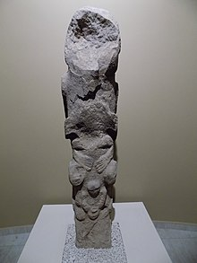](https://en.wikipedia.org/wiki/File:%C5%9Eanl%C4%B1urfa_M%C3%BCzesi_Neotilik_%C3%87a%C4%9F_totem.jpg)

A sort of a totem pole from Göbekli Tepe, Layer II, 8800-8000 BC - [Şanlıurfa (Urfa) Museum](https://en.wikipedia.org/wiki/Sanliurfa_Museum)

Creation of the circular enclosures in layer III later gave way to the construction of small rectangular rooms in layer II. Rectangular buildings make a more efficient use of space compared with circular structures. They are often associated with the emergence of the Neolithic.[[24]](https://en.wikipedia.org/wiki/G%C3%B6bekli_Tepe#cite_note-24) But the T-shaped pillars, the main feature of the older enclosures, are also present here, indicating that the buildings of Layer II continued to serve as sanctuaries.[[25]](https://en.wikipedia.org/wiki/G%C3%B6bekli_Tepe#cite_note-25) Layer II is assigned to [Pre-Pottery Neolithic B](https://en.wikipedia.org/wiki/Pre-Pottery_Neolithic_B) (PPNB). The several adjoining rectangular, doorless and windowless rooms have floors of polished lime reminiscent of [Roman](https://en.wikipedia.org/wiki/Ancient_Rome) terrazzo floors. Carbon dating has yielded dates between 8800 and 8000 BCE.[[26]](https://en.wikipedia.org/wiki/G%C3%B6bekli_Tepe#cite_note-26) Several T-pillars up to 1.5 meters tall occupy the center of the rooms. A pair decorated with fierce-looking lions is responsible for the name "lion pillar building" by which their enclosure is known.[[27]](https://en.wikipedia.org/wiki/G%C3%B6bekli_Tepe#cite_note-27)

A sort of a stone totem pole was discovered at Göbekli Tepe, Layer II in 2010. It is 1.92 metres high, and is superficially reminiscent of those in North America. The pole features three figures, the uppermost depicting a predator, probably a bear, and below it a human-like shape. Because the statue is damaged, the interpretation is not entirely clear. Fragments of a similar pole were discovered about 20 years ago in [Nevalı Çori](https://en.wikipedia.org/wiki/Neval%C4%B1_%C3%87ori), also in Turkey. Also, an older layer at Gobekli does feature some related sculptures portraying animals on human heads.[[28]](https://en.wikipedia.org/wiki/G%C3%B6bekli_Tepe#cite_note-28)

**Layer I**

Layer I is the uppermost part of the hill. It is the shallowest, but accounts for the longest stretch of time. It consists of loose sediments caused by erosion and the virtually uninterrupted use of the hill for agricultural purposes since it ceased to operate as a cult center.

The site was deliberately [backfilled](https://en.wikipedia.org/wiki/Earthworks_(engineering)) sometime after 8000 BCE: the buildings were buried under debris, mostly flint gravel, stone tools, and animal bones.[[29]](https://en.wikipedia.org/wiki/G%C3%B6bekli_Tepe#cite_note-29) In addition to [Byblos](https://en.wikipedia.org/wiki/Byblos) points (weapon heads, i.e. arrowheads etc.) and numerous [Nemrik](https://en.wikipedia.org/wiki/Nemrik) points, [Helwan](https://en.wikipedia.org/wiki/Helwan)-points and [Aswad](https://en.wikipedia.org/wiki/Tell_Aswad)-points dominate the backfill's lithic inventory.

**Chronological context**

All statements about the site must be considered preliminary, as less than 5% of the site has been excavated, and Schmidt planned to leave much of it untouched to be explored by future generations when archaeological techniques will presumably have improved.[[10]](https://en.wikipedia.org/wiki/G%C3%B6bekli_Tepe#cite_note-Smithsonian-10) While the site formally belongs to the earliest Neolithic ([PPNA](https://en.wikipedia.org/wiki/Pre-Pottery_Neolithic_A)), up to now no traces of domesticated plants or animals have been found. The inhabitants are assumed to have been [hunters and gatherers](https://en.wikipedia.org/wiki/Hunters_and_gatherers) who nevertheless lived in villages for at least part of the year.[[30]](https://en.wikipedia.org/wiki/G%C3%B6bekli_Tepe#cite_note-30) So far, very little evidence for [residential](https://en.wikipedia.org/wiki/Residential) use has been found. Through the [radiocarbon](https://en.wikipedia.org/wiki/Radiocarbon_dating) method, the end of Layer III can be fixed at about 9000 BCE (see above) but it is believed that the elevated location may have functioned as a spiritual center by 11,000 BCE or even earlier, essentially at the very end of the [Pleistocene](https://en.wikipedia.org/wiki/Pleistocene).

The surviving structures, then, not only predate [pottery](https://en.wikipedia.org/wiki/Pottery), [metallurgy](https://en.wikipedia.org/wiki/Metallurgy), and the invention of [writing](https://en.wikipedia.org/wiki/Writing) or the [wheel](https://en.wikipedia.org/wiki/Wheel), but were built before the so-called [Neolithic Revolution](https://en.wikipedia.org/wiki/Neolithic_Revolution), i.e., the beginning of [agriculture](https://en.wikipedia.org/wiki/Agriculture) and [animal husbandry](https://en.wikipedia.org/wiki/Animal_husbandry) around 9000 BCE. But the construction of Göbekli Tepe implies organization of an advanced order not hitherto associated with [Paleolithic](https://en.wikipedia.org/wiki/Paleolithic), [PPNA](https://en.wikipedia.org/wiki/Pre-Pottery_Neolithic_A), or [PPNB](https://en.wikipedia.org/wiki/Pre-Pottery_Neolithic_B) societies. Archaeologists estimate that up to 500 persons were required to extract the heavy pillars from local [quarries](https://en.wikipedia.org/wiki/Quarry) and move them 100–500 meters (330–1,640 ft) to the site.[[31]](https://en.wikipedia.org/wiki/G%C3%B6bekli_Tepe#cite_note-31) The pillars weigh 10–20 metric tons (10–20 [long tons](https://en.wikipedia.org/wiki/Long_ton); 11–22 [short tons](https://en.wikipedia.org/wiki/Short_ton)), with one still in the quarry weighing 50 tons.[[32]](https://en.wikipedia.org/wiki/G%C3%B6bekli_Tepe#cite_note-32)

Around the beginning of the 8th millennium BCE Göbekli Tepe lost its importance. The advent of agriculture and animal husbandry brought new realities to human life in the area, and the "Stone-age zoo" (Schmidt's phrase applied particularly to Layer III, Enclosure D) apparently lost whatever significance it had had for the region's older, foraging communities. But the complex was not simply abandoned and forgotten to be gradually destroyed by the elements. Instead, each enclosure was deliberately buried under as much as 300 to 500 cubic meters (390 to 650 cu yd) of refuse consisting mainly of small limestone fragments, stone vessels, and stone tools. Many animal, even human, bones have also been identified in the fill.[[33]](https://en.wikipedia.org/wiki/G%C3%B6bekli_Tepe#cite_note-33) Why the enclosures were buried is unknown, but it preserved them for posterity.

**Interpretation**

[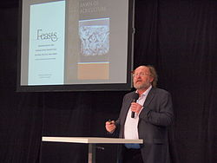](https://en.wikipedia.org/wiki/File:Klaus_Schmidt_Monumento_2014_5.jpg)

Klaus Schmidt, 2014 in Salzburg

[Schmidt](https://en.wikipedia.org/wiki/Klaus_Schmidt_(archaeologist))'s view was that Göbekli Tepe is a stone-age mountain sanctuary. [Radiocarbon dating](https://en.wikipedia.org/wiki/Radiocarbon_dating) as well as comparative, stylistical analysis indicate that it is the oldest religious site yet discovered anywhere.[[10]](https://en.wikipedia.org/wiki/G%C3%B6bekli_Tepe#cite_note-Smithsonian-10)[[34]](https://en.wikipedia.org/wiki/G%C3%B6bekli_Tepe#cite_note-ArchMag-34) Schmidt believed that what he called this "cathedral on a hill" was a pilgrimage destination attracting worshippers up to 150 km (90 mi) distant. Butchered bones found in large numbers from local game such as deer, gazelle, pigs, and geese have been identified as refuse from food hunted and cooked or otherwise prepared for the congregants.[[35]](https://en.wikipedia.org/wiki/G%C3%B6bekli_Tepe#cite_note-35)

Schmidt considered Göbekli Tepe a central location for a [cult of the dead](https://en.wikipedia.org/wiki/Veneration_of_the_dead) and that the carved animals are there to protect the dead. Though no tombs or graves have been found so far, Schmidt believed that they remain to be discovered in niches located behind the sacred circles' walls.[[10]](https://en.wikipedia.org/wiki/G%C3%B6bekli_Tepe#cite_note-Smithsonian-10)

In 2017, discovery of human crania with incisions were reported, interpreted as providing evidence for a new form of Neolithic skull cult.[[36]](https://en.wikipedia.org/wiki/G%C3%B6bekli_Tepe#cite_note-36)

Schmidt also interpreted it in connection with the initial stages of the [Neolithic](https://en.wikipedia.org/wiki/Neolithic).[[10]](https://en.wikipedia.org/wiki/G%C3%B6bekli_Tepe#cite_note-Smithsonian-10) It is one of several sites in the vicinity of [Karaca Dağ](https://en.wikipedia.org/wiki/Karaca_Da%C4%9F), an area which [geneticists](https://en.wikipedia.org/wiki/Genetics) suspect may have been the original source of at least some of our cultivated grains (see [Einkorn](https://en.wikipedia.org/wiki/Einkorn)). Recent DNA analysis of modern domesticated wheat compared with wild wheat has shown that its DNA is closest in sequence to wild wheat found on [Karaca Dağ](https://en.wikipedia.org/wiki/Karaca_Da%C4%9F) 30 km (20 mi) away from the site, suggesting that this is where modern wheat was first domesticated.[[37]](https://en.wikipedia.org/wiki/G%C3%B6bekli_Tepe#cite_note-37) Such scholars suggest that the [Neolithic revolution](https://en.wikipedia.org/wiki/Neolithic_revolution), in particular the beginnings of grain cultivation (i.e. *not* animal husbandry) took place here. Schmidt believed, as others do, that mobile groups in the area were compelled to cooperate with each other to protect early concentrations of wild cereals from wild animals (herds of gazelles and wild donkeys). Wild [cereals](https://en.wikipedia.org/wiki/Cereals) may have been used for sustenance more intensively than before and were perhaps deliberately [cultivated](https://en.wikipedia.org/wiki/Plant_cultivation). This would have led to early social organization of various groups in the area of Göbekli Tepe. Thus, according to Schmidt, the Neolithic did not begin on a small scale in the form of individual instances of garden cultivation, but developed rapidly in the form of "a large-scale social organization".[[38]](https://en.wikipedia.org/wiki/G%C3%B6bekli_Tepe#cite_note-38)

With its mountains catching the rain and a calcareous, porous bedrock creating lots of springs, creeks and rivers[[39]](https://en.wikipedia.org/wiki/G%C3%B6bekli_Tepe#cite_note-:2-39) the upper reaches of the Euphrates and Tigris was a refuge during the dry and cold [Younger Dryas](https://en.wikipedia.org/wiki/Younger_Dryas) climatic event (10,800 – 9,500 BCE). Crowded conditions could have led these people to develop common rituals strengthened by monumental gathering places to reduce tensions and conflicts over resources[[40]](https://en.wikipedia.org/wiki/G%C3%B6bekli_Tepe#cite_note-40), and probably to mark territorial claims.

Schmidt engaged in some speculation regarding the belief systems of the groups that created Göbekli Tepe, based on comparisons with other shrines and settlements. He assumed [shamanic](https://en.wikipedia.org/wiki/Shamanism) practices and suggested that the T-shaped pillars represent human forms, perhaps [ancestors](https://en.wikipedia.org/wiki/Ancestors), whereas he saw a fully articulated belief in gods only developing later in [Mesopotamia](https://en.wikipedia.org/wiki/Mesopotamia), associated with extensive [temples](https://en.wikipedia.org/wiki/Temple) and [palaces](https://en.wikipedia.org/wiki/Palace). This corresponds well with an ancient [Sumerian](https://en.wikipedia.org/wiki/Sumer) belief that agriculture, animal husbandry, and weaving were brought to mankind from the sacred mountain [Ekur](https://en.wikipedia.org/wiki/Ekur), which was inhabited by [Annuna](https://en.wikipedia.org/wiki/Annuna) deities, very ancient gods without individual names. Schmidt identified this story as a primeval oriental myth that preserves a partial memory of the emerging Neolithic.[[41]](https://en.wikipedia.org/wiki/G%C3%B6bekli_Tepe#cite_note-41) It is also apparent that the animal and other images give no indication of organized violence, i.e. there are no depictions of hunting raids or wounded animals, and the pillar carvings generally ignore game on which the society depended, such as deer, in favor of formidable creatures such as lions, snakes, spiders, and scorpions.[[10]](https://en.wikipedia.org/wiki/G%C3%B6bekli_Tepe#cite_note-Smithsonian-10)[[42]](https://en.wikipedia.org/wiki/G%C3%B6bekli_Tepe#cite_note-42)[[43]](https://en.wikipedia.org/wiki/G%C3%B6bekli_Tepe#cite_note-43) Expanding on Schmidt's interpretation that round enclosures could represent sanctuaries, Gheorghiu's semiotic interpretation reads Göbekli Tepe's iconography as a cosmogonic map which would have related the local community to the surrounding landscape and the cosmos.[[44]](https://en.wikipedia.org/wiki/G%C3%B6bekli_Tepe#cite_note-44)

**Importance**

Göbekli Tepe is regarded by some as an archaeological discovery of the greatest importance since it could profoundly change the understanding of a crucial stage in the development of human society. [Ian Hodder](https://en.wikipedia.org/wiki/Ian_Hodder) of Stanford University said, "Göbekli Tepe changes everything".[[2]](https://en.wikipedia.org/wiki/G%C3%B6bekli_Tepe#cite_note-:0-2)[[45]](https://en.wikipedia.org/wiki/G%C3%B6bekli_Tepe#cite_note-45) If indeed the site was built by [hunter-gatherers](https://en.wikipedia.org/wiki/Hunter-gatherer) as some researchers believe then it would mean that the ability to erect monumental complexes was within the capacities of these sorts of groups which would overturn previous assumptions. Some researchers believe that the construction of Göbekli Tepe may have contributed to the later development of urban civilization. As excavator Klaus Schmidt put it: "First came the temple, then the city."[[46]](https://en.wikipedia.org/wiki/G%C3%B6bekli_Tepe#cite_note-46)

[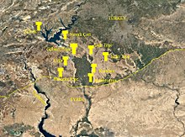](https://en.wikipedia.org/wiki/File:T-shaped-pillars-PPN.jpg)

Sites with T-shaped pillars from the PPN

Not only its large dimensions, but the side-by-side existence of multiple pillar shrines makes the location unique. There are no comparable monumental complexes from its time. However, since its discovery surface surveys have shown that several hills in the greater area also have T-shaped stone pillars (e.g. Hamzan Tepe[[47]](https://en.wikipedia.org/wiki/G%C3%B6bekli_Tepe" \l "cite_note-47), Karahan Tepe[[48]](https://en.wikipedia.org/wiki/G%C3%B6bekli_Tepe" \l "cite_note-48), Harbetsuvan Tepesi[[49]](https://en.wikipedia.org/wiki/G%C3%B6bekli_Tepe" \l "cite_note-49), Sefer Tepe[[50]](https://en.wikipedia.org/wiki/G%C3%B6bekli_Tepe" \l "cite_note-:1-50), Taslı Tepe[[39]](https://en.wikipedia.org/wiki/G%C3%B6bekli_Tepe" \l "cite_note-:2-39)), but there has so far not been much excavation done. Most of these constructions seem to be smaller than Göbekli Tepe, and their placement evenly between contemporary settlements[[50]](https://en.wikipedia.org/wiki/G%C3%B6bekli_Tepe#cite_note-:1-50)[[39]](https://en.wikipedia.org/wiki/G%C3%B6bekli_Tepe#cite_note-:2-39) indicate that they were local social/ritual gathering places, with Göbekli Tepe maybe as a regional centre[[51]](https://en.wikipedia.org/wiki/G%C3%B6bekli_Tepe" \l "cite_note-51). So far none of the smaller sites are as old as the lowest Level III of Göbekli Tepe[[39]](https://en.wikipedia.org/wiki/G%C3%B6bekli_Tepe" \l "cite_note-:2-39), but contemporary with its younger Level II (mostly rectangular buildings, though Harbetsuvan is circular). This could indicate that this type of architecture and associated activities originated at Göbekli Tepe and then spread to other sites.[[*citation needed*](https://en.wikipedia.org/wiki/Wikipedia:Citation_needed)]

A 500 years younger site is [Nevalı Çori](https://en.wikipedia.org/wiki/Nevali_Cori), a Neolithic settlement also excavated by the [German Archaeological Institute](https://en.wikipedia.org/wiki/German_Archaeological_Institute) and submerged by the [Atatürk Dam](https://en.wikipedia.org/wiki/Atat%C3%BCrk_Dam) since 1992. Its T-shaped pillars are considerably smaller, and its rectangular shrine was located inside a village. The roughly contemporary architecture at [Jericho](https://en.wikipedia.org/wiki/Jericho) is devoid of artistic merit or large-scale sculpture, and [Çatalhöyük](https://en.wikipedia.org/wiki/%C3%87atalh%C3%B6y%C3%BCk), perhaps the most famous Anatolian Neolithic village, is 2,000 years later.

At present Göbekli Tepe raises more questions for [archaeology](https://en.wikipedia.org/wiki/Archaeology) and [prehistory](https://en.wikipedia.org/wiki/Prehistory) than it answers. It remains unknown how a force large enough to construct, augment, and maintain such a substantial complex was mobilized and compensated or fed in the conditions of pre-sedentary society. Scholars cannot interpret the pictograms, and do not know for certain what meaning the animal reliefs had for visitors to the site; the variety of fauna depicted, from lions and boars to birds and insects, makes any single explanation problematic. As there is little or no evidence of habitation, and the animals pictured are mainly predators, the stones may have been intended to [stave off evils](https://en.wikipedia.org/wiki/Apotropaic_magic) through some form of magic representation. Alternatively, they could have served as [totems](https://en.wikipedia.org/wiki/Totem).[[52]](https://en.wikipedia.org/wiki/G%C3%B6bekli_Tepe#cite_note-52) The assumption that the site was strictly cultic in purpose and not inhabited has also been challenged by the suggestion that the structures served as large communal houses, "similar in some ways to the large plank houses of the Northwest Coast of North America with their impressive house posts and totem poles."[[53]](https://en.wikipedia.org/wiki/G%C3%B6bekli_Tepe#cite_note-53) It is not known why every few decades the existing pillars were buried to be replaced by new stones as part of a smaller, concentric ring inside the older one.[[54]](https://en.wikipedia.org/wiki/G%C3%B6bekli_Tepe#cite_note-54) Human burial may have occurred at the site. The reason the complex was carefully backfilled remains unexplained. Until more evidence is gathered, it is difficult to deduce anything certain about the originating culture or the site's significance.

**Conservation**

[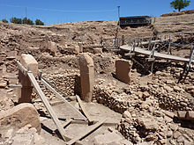](https://en.wikipedia.org/wiki/File:G%C3%B6bekli_Tepe_site_(2).JPG)

Göbekli Tepe

Future plans include construction of a museum and converting the environs into an archaeological park in the hope that this will help preserve the site in the state in which it was discovered.[[55]](https://en.wikipedia.org/wiki/G%C3%B6bekli_Tepe#cite_note-55)

In 2010, [Global Heritage Fund](https://en.wikipedia.org/wiki/Global_Heritage_Fund) (GHF) announced it will undertake a multi-year conservation program to preserve Göbekli Tepe. Partners include the [German Archaeological Institute](https://en.wikipedia.org/wiki/German_Archaeological_Institute), [German Research Foundation](https://en.wikipedia.org/wiki/German_Research_Foundation), [Şanlıurfa](https://en.wikipedia.org/wiki/%C5%9Eanl%C4%B1urfa) Municipal Government, the Turkish Ministry of Tourism and Culture and, formerly, Klaus Schmidt.[[56]](https://en.wikipedia.org/wiki/G%C3%B6bekli_Tepe#cite_note-56)

The stated goals of the GHF Göbekli Tepe project are to support the preparation of a site management and conservation plan, construction of a shelter over the exposed archaeological features, training community members in guiding and conservation, and helping Turkish authorities secure UNESCO [World Heritage Site](https://en.wikipedia.org/wiki/World_Heritage_Site) designation for GT.[[57]](https://en.wikipedia.org/wiki/G%C3%B6bekli_Tepe#cite_note-GHF-57)

The conservation work caused controversy in 2018, when Çiğdem Köksal Schmidt, an archaeologist and widow of Klaus Schmidt, said the site was being damaged by the use of concrete and "heavy equipment" during the construction of a new walkway. The [Ministry of Culture and Tourism](https://en.wikipedia.org/wiki/Ministry_of_Culture_and_Tourism_(Turkey)) responded that no concrete was used and that no damage had occurred.[[58]](https://en.wikipedia.org/wiki/G%C3%B6bekli_Tepe#cite_note-58)[[59]](https://en.wikipedia.org/wiki/G%C3%B6bekli_Tepe#cite_note-59)

**See also**

* [Gürcütepe](https://en.wikipedia.org/wiki/G%C3%BCrc%C3%BCtepe)
* [History of Turkey](https://en.wikipedia.org/wiki/History_of_Turkey)
* [List of archaeological sites by continent and age](https://en.wikipedia.org/wiki/List_of_archaeological_sites_by_continent_and_age)
* [List of megalithic sites](https://en.wikipedia.org/wiki/List_of_megalithic_sites)
* [Natufian culture](https://en.wikipedia.org/wiki/Natufian_culture)
* [Nevalı Çori](https://en.wikipedia.org/wiki/Neval%C4%B1_%C3%87ori) - a temple site thought to be very similar to Göbekli Tepe.
* [Prehistoric religion](https://en.wikipedia.org/wiki/Prehistoric_religion)
* [Tell Aswad](https://en.wikipedia.org/wiki/Tell_Aswad) – a c.9000 BCE site in Syria.

**Notes**

• [*"Göbekli Tepe"*](http://www.forvo.com/word/g%C3%B6bekli_tepe/)*. Forvo Pronunciation Dictionary.*

• • *"History in the Remaking". Newsweek. 18 Feb 2010.*

• • Klaus Schmidt (2009): *Göbekli Tepe - Eine Beschreibung der wichtigsten Befunde erstellt nach den Arbeiten der Grabungsteams der Jahre 1995-2007*. In: *Erste Tempel - Frühe Siedlungen. 12000 Jahre Kunst und Kultur.* Oldenburg, p. 188.

• • *Sagona, Claudia.* [*The Archaeology of Malta*](https://books.google.com/books?id=qR5TCgAAQBAJ&pg=PA47)*. Cambridge University Press. p. 47.* [*ISBN*](https://en.wikipedia.org/wiki/International_Standard_Book_Number)[*9781107006690*](https://en.wikipedia.org/wiki/Special:BookSources/9781107006690)*. Retrieved 25 November 2016.*

• • *Curry, Andrew (November 2008).* [*"Gobekli Tepe: The World's First Temple?"*](http://www.smithsonianmag.com/history-archaeology/gobekli-tepe.html)*. Smithsonian.com. Retrieved August 2, 2013.*

• • Peter Benedict (1980): *Survey Work in Southeastern Anatolia*. In: Halet Çambel; Robert J. Braidwood (ed.): *Prehistoric Research in Southeastern Anatolia I*. Edebiyat Fakültesi Basimevi, Istanbul, pp. 151–191.

• • *Schmidt, Klaus (2011). "Göbekli Tepe: A Neolithic Site in Southwestern Anatolia". In Steadman, Sharon R.; McMahon, Gregory.* [*The Oxford Handbook of Ancient Anatolia*](https://books.google.com/books?id=TY3t4y_L5SQC&pg=PA917)*. Oxford: Oxford University Press. p. 917.* [*ISBN*](https://en.wikipedia.org/wiki/International_Standard_Book_Number)[*9780195376142*](https://en.wikipedia.org/wiki/Special:BookSources/9780195376142)*.*

• • [*"Turkey's Ancient Sanctuary"*](https://www.newyorker.com/magazine/2011/12/19/the-sanctuary)*. The New Yorker. Retrieved 2017-08-26.*

• • [*"World's Oldest Monument to Receive a Multi-Million Dollar Investment"*](http://www.history.com/news/worlds-oldest-monument-to-receive-a-multi-million-dollar-investment)*. HISTORY.com. Retrieved 2017-08-26.*

• • *Curry, Andrew (November 2008).* [*"Göbekli Tepe: The World's First Temple?"*](http://www.smithsonianmag.com/history-archaeology/30706129.html)*. Smithsonian Institution. Retrieved 2009-03-14.*

• • [Upper Mesopotamia (SE Turkey, N Syria and N Iraq) 14C databases: 11th–6th millennia cal BCE](https://web.archive.org/web/20090313082449/http:/www.canew.org/uppermesop14cbox.html)

• • Klaus Schmidt: *Sie bauten die ersten Tempel. Das rätselhafte Heiligtum der Steinzeitjäger. Die archäologische Entdeckung am Göbekli Tepe.* Munich 2006, p. 102.

• • Klaus Schmidt: *Göbekli Tepe. Eine Beschreibung der wichtigsten Befunde erstellt nach den Arbeiten der Grabungsteams der Jahre 1995-2007*. In: *Erste Tempel - Frühe Siedlungen. 12000 Jahre Kunst und Kultur. Ausgrabungen und Forschungen zwischen Donau und Euphrat. Oldenburg 2009, p. 188.*

• • Schmidt 2006, p. 105

• • Schmidt 2006, pp. 109-111

• • Schmidt 2006, p. 111

• • Schmidt 2006, p. 109

• • Schmidt 2000b, pp. 52–53

• • Mithen 2004, p. 65

• • Mithen 2004, pp. 93–96.

• • Peters & Schmidt 2004, p. 214

• • Schmidt 2010, pp. 244, 246

• • Schmidt, 2010, p. 251.

• • Flannery and Marcus, *The Creation of Inequality*, p. 128

• • Schmidt 2010, pp. 239, 241.

• • Schmidt 2009, p. 291

• • Schmidt 1990, p. 198

• • [The Göbekli Tepe ‘Totem Pole’.](https://tepetelegrams.wordpress.com/2017/03/01/the-gobekli-tepe-totem-pole/) News & Notes from the Göbekli Tepe Research Staff - 03/01/2017

• • Schmidt 2010, p. 242

• • The Guardian report 23 April 2008

• • [*"Which came first, monumental building projects or farming?"*](http://www.stonepages.com/news/archives/003061.html)*. Archaeo News. 14 December 2008.*

• • *Taracha, Piotr (2009).* [*Religions of second millennium Anatolia*](https://books.google.com/books?id=xTE7o8aKI7IC&pg=PA12&dq=%22G%C3%B6bekli+Tepe%22+%2250+tons%22#v=onepage&q&f=false)*. Eisenbrauns. p. 12.* [*ISBN*](https://en.wikipedia.org/wiki/International_Standard_Book_Number)[*978-3-447-05885-8*](https://en.wikipedia.org/wiki/Special:BookSources/978-3-447-05885-8)*.*

• • Schmidt 2010, pp. 242—243, 249.

• • [*"The World's First Temple"*](http://www.archaeology.org/0811/abstracts/turkey.html)*. Archaeology magazine. Nov–Dec 2008. p. 23.*

• • Peters & Schmidt 2004, 207

• • Julia Gresky, Juliane Haelm and Lee Clare, "Modified human crania from Göbekli Tepe provide evidence for a new form of Neolithic skull cult", Science Advances, Vol. 3, no. 6, 28 Jun 2017. DOI:10.1126/sciadv.1700564 [(full text)](http://advances.sciencemag.org/content/3/6/e1700564.full).

• • Heun et al., *Site of Einkorn Wheat Domestication Identified by DNA Fingerprinting*, Science, 278 (1997) 1312–14.

• • Klaus-Dieter Linsmeier: *Eine Revolution im großen Stil.* Interview mit Klaus Schmidt. In: *Abenteuer Archäologie. Kulturen, Menschen, Monumente.* Spektrum der Wissenschaft, Heidelberg 2006, 2, [ISSN](https://en.wikipedia.org/wiki/International_Standard_Serial_Number) [1612-9954](https://www.worldcat.org/search?fq=x0:jrnl&q=n2:1612-9954)

• • *Güler, Çelik, Güler (2013).* [*"New Pre-Pottery Neolithic sites and cult centres in the Urfa Region"*](https://revije.ff.uni-lj.si/DocumentaPraehistorica/article/view/40.23/817)*.*

• • *Oliver, Dietrich (June 1, 2017).* [*"Cooperative Action of Hunter-Gatherers in the Early Neolithic Near East. A View from Göbekli Tepe"*](https://tepetelegrams.wordpress.com/2017/06/01/cooperative-action-of-hunter-gatherers-in-the-early-neolithic-near-east-a-view-from-goebekli-tepe/)*.*

• • Schmidt 2006, pp. 216–221

• • Schmidt 2006, pp. 193–4; 218.

• • Peters & Schmidt 2004, p. 209

• • Dragos Gheorghiu (2015); *A river runs through it. The semiotics of Gobekli Tepe's map (an exercise of archaeological imagination)*; in Andrea Vianello (ed.), *Rivers in Prehistory*, Oxford, Archaeopress

• • <http://www.newsweek.com/turkey-archeological-dig-reshaping-human-history-75101>

• • K. Schmidt 2000: "Zuerst kam der Tempel, dann die Stadt."

• • *Çelik, Bahattin (2010).* [*"Hamzan Tepe in the light of new finds"*](https://revije.ff.uni-lj.si/DocumentaPraehistorica/article/view/37.22/1714)*.*

• • *Çelik, Bahattin (2011).* [*"Karahan Tepe: a new cultural centre in the Urfa Area in Turkey"*](https://revije.ff.uni-lj.si/DocumentaPraehistorica/article/view/38.19/1651)*.*

• • *Çelik, Bahattin.* [*"A small-scale cult centre in Southeast Turkey: Harbetsuvan Tepesi"*](https://revije.ff.uni-lj.si/DocumentaPraehistorica/article/view/43.21)*.*

• • *Güler, Çelik, Güler.* [*"New pre-pottery neolithic settlements from Viranşehir District"*](http://dergiler.ankara.edu.tr/dergiler/14/1790/18894.pdf) *(PDF).*

• • *Simmons, Alan H.* [*"The Neolithic Revolution in the Near East: Transforming the Human Landscape"*](https://books.google.com/books?id=C-ysw2gdT9IC&pg=PA110&lpg=PA110&dq=Urfa-Yeni+Yol&source=bl&ots=LuggnTBH62&sig=RM86IxQIvhOUu2jzyyaYHJbfQwc&hl=no&sa=X&ved=0ahUKEwjsqNSCoPjVAhXEKJoKHd51CxoQ6AEIZjAN#v=onepage&q=Urfa-Yeni%20Yol&f=false)*. University of Arizona Press via Google Books.*

• • Peters & Schmidt 2004: pp. 209–212

• • Banning 2011

• • Mann, June 2011, p. 48

• • K. Schmidt in Schmidt (ed.) 2009, p. 188.

• • "GHF - Göbekli Tepe - Turkey", globalheritagefund.org, web: [GHF2](http://globalheritagefund.org/what_we_do/preservation_by_design_partnerships/current_projects/gobekli_tepe_turkey) [Archived](https://web.archive.org/web/20110705232017/http:/globalheritagefund.org/what_we_do/preservation_by_design_partnerships/current_projects/gobekli_tepe_turkey) 5 July 2011 at the [Wayback Machine](https://en.wikipedia.org/wiki/Wayback_Machine)..

• • "GHF - Gobekli Tepe, Turkey - Overview", globalheritagefund.org: [GHF3](http://globalheritagefund.org/what_we_do/overview/current_projects/gobekli_tepe_turkey).

• • [*"Concrete poured on Turkish World Heritage site"*](https://ahvalnews.com/turkey/concrete-poured-turkish-world-heritage-site)*. Ahval. 21 March 2018. Retrieved 2018-03-26.*

* 1. • [*"Construction around site of Göbeklitepe stirs debate"*](http://www.hurriyetdailynews.com/construction-around-site-of-gobeklitepe-stirs-debate-129089)*. Hürriyet Daily News. 21 March 2018. Retrieved 2018-03-26.*

**References**

* Badisches Landesmuseum Karlsruhe (ed.): *Vor 12.000 Jahren in Anatolien. Die ältesten Monumente der Menschheit.* Begleitbuch zur Ausstellung im Badischen Landesmuseum vom 20. Januar bis zum 17. Juni 2007. Theiss, Stuttgart 2007, [ISBN](https://en.wikipedia.org/wiki/International_Standard_Book_Number) [978-3-8062-2072-8](https://en.wikipedia.org/wiki/Special:BookSources/978-3-8062-2072-8)
* E.B. Banning, "So Fair a House: Göbekli Tepe and the Identification of Temples in the Pre-Pottery Neolithic of the Near East", Current Anthropology, 52.5 (October 2011), 619 ff.: <https://www.scribd.com/doc/67961270/Gobekli-Tepe-temples-Ted-Banning-2011>
* Andrew Curry, "Seeking the Roots of Ritual," Science 319 (18 January 2008), pp. 278–80: [https://web.archive.org/web/20120415112503/http://80.251.40.59/veterinary.ankara.edu.tr/fidanci/Yasam/Gelecege\_Miras/Gobekli-Tepe.pdf](https://web.archive.org/web/20120415112503/http:/80.251.40.59/veterinary.ankara.edu.tr/fidanci/Yasam/Gelecege_Miras/Gobekli-Tepe.pdf)
* Andrew Curry, "Göbekli Tepe: The World’s First Temple?". Smithsonian Magazine (November 2008): <http://www.smithsonianmag.com/history-archaeology/gobekli-tepe.html>
* DVD-ROM: MediaCultura (Hrsg.): *Vor 12.000 Jahren in Anatolien. Die ältesten Monumente der Menschheit.* Theiss, Stuttgart 2007, [ISBN](https://en.wikipedia.org/wiki/International_Standard_Book_Number) [978-3-8062-2090-2](https://en.wikipedia.org/wiki/Special:BookSources/978-3-8062-2090-2)
* Kent Flannery and Joyce Marcus, *The Creation of Inequality* (Cambridge and London, 2012), pp. 128–131.
* David Lewis-Williams and David Pearce, "An Accidental revolution? Early Neolithic religion and economic change", *Minerva*, 17 #4 (July/August, 2006), 29–31.
* Klaus-Dieter Linsmeier and Klaus Schmidt: *Ein anatolisches Stonehenge.* In: *Moderne Archäologie.* Spektrum-der-Wissenschaft-Verlag, Heidelberg 2003, 10–15, [ISBN](https://en.wikipedia.org/wiki/International_Standard_Book_Number) [3-936278-35-0](https://en.wikipedia.org/wiki/Special:BookSources/3-936278-35-0).
* Charles C. Mann, "The Birth of Religion: The World's First Temple" National Geographic Vol. 219 No. 6 (June 2011), pp. 34–59: <http://ngm.nationalgeographic.com/2011/06/gobekli-tepe/mann-text>
* Steven Mithen, *After the Ice:A global human history, 20,000-5000 BC*. Harvard University Press, Cambridge MA, 2004, [ISBN](https://en.wikipedia.org/wiki/International_Standard_Book_Number) [0-674-01570-3](https://en.wikipedia.org/wiki/Special:BookSources/0-674-01570-3). Pp. 65–69, 89–90.
* J. Peters & K. Schmidt: "Animals in the symbolic world of Pre-Pottery Neolithic Göbekli Tepe, south-eastern Turkey: a preliminary assessment." Anthropozoologica 39.1 (2004), 179–218: [https://web.archive.org/web/20110612061638/http://www.mnhn.fr/museum/front/medias/publication/10613\_Peters.pdf](https://web.archive.org/web/20110612061638/http:/www.mnhn.fr/museum/front/medias/publication/10613_Peters.pdf).
* K. Pustovoytov: *Weathering rinds at exposed surfaces of limestone at Göbekli Tepe*. In: *Neo-lithics.* Ex Oriente, Berlin 2000, 24–26 (14C-Dates)
* Erika Qasim: "The T-shaped monuments of Gobekli Tepe: Posture of the Arms*. In: Chr. Sütterlin et al. (ed.): Art as Behaviour. An Ethological Appraoch to Visual and Verbal Art, Music and Architecture. Oldenburg 2014, 252-272*
* Sandra Scham, "The World's First Temple," Archaeology 61.6 (November/December 2008): <http://www.archaeology.org/0811/abstracts/turkey.html>
* K. Schmidt: *Frühneolithische Tempel. Ein Forschungsbericht zum präkeramischen Neolithikum Obermesopotamiens.* In: Mitteilungen der deutschen Orient-Gesellschaft 130, Berlin 1998, 17–49, [ISSN](https://en.wikipedia.org/wiki/International_Standard_Serial_Number) [0342-118X](https://www.worldcat.org/search?fq=x0:jrnl&q=n2:0342-118X)
* K. Schmidt: "Zuerst kam der Tempel, dann die Stadt." Vorläufiger Bericht zu den Grabungen am Göbekli Tepe und am Gürcütepe 1995–1999. Istanbuler Mitteilungen 50 (2000): 5–41.
* K. Schmidt, 2000a = Göbekli Tepe and the rock art of the Near East, *TÜBA-AR* 3 (2000): 1–14.
* K. Schmidt, 2000b = *Göbekli Tepe, Southeastern Turkey. A preliminary Report on the 1995–1999 Excavations.* In: *Palèorient* CNRS Ed., Paris 2000: 26.1, 45–54, [ISSN](https://en.wikipedia.org/wiki/International_Standard_Serial_Number) [0153-9345](https://www.worldcat.org/search?fq=x0:jrnl&q=n2:0153-9345): <http://www.persee.fr/web/revues/home/prescript/article/paleo_0153-9345_2000_num_26_1_4697>
* K. Schmidt: *Sie bauten die ersten Tempel. Das rätselhafte Heiligtum der Steinzeitjäger*. Verlag C.H. Beck, München 2006, [ISBN](https://en.wikipedia.org/wiki/International_Standard_Book_Number) [3-406-53500-3](https://en.wikipedia.org/wiki/Special:BookSources/3-406-53500-3).
* K. Schmidt, "Göbekli Tepe. Eine Beschreibung der wichtigsten Befunde erstellt nach den Arbeiten der Grabungsteams der Jahre 1995–2007", in K. Schmidt (ed.), *Erste Tempel—Frühe Siedlungen. 12000 Jahre Kunst und Kultur, Ausgrabungen und Forschungen zwischen Donau und Euphrat*, (Oldenburg 2009): 187–233.
* K. Schmidt, "Göbekli Tepe—the Stone Age Sanctuaries: New results of ongoing excavations with a special focus on sculptures and high reliefs," Documenta Praehistorica XXXVII (2010), 239–256: [https://web.archive.org/web/20120131114925/http://arheologija.ff.uni-lj.si/documenta/authors37/37\_21.pdf](https://web.archive.org/web/20120131114925/http:/arheologija.ff.uni-lj.si/documenta/authors37/37_21.pdf)
* Metin Yeşilyurt, Die wissenschaftliche Interpretation von Göbeklitepe: Die Theorie und das Forschungsprogramm. (Neolithikum und ältere Metallzeiten. Studien und Materialien, Band 2.) Lit Verlag, Berlin 2014, [ISBN](https://en.wikipedia.org/wiki/International_Standard_Book_Number) [978-3-643-12528-6](https://en.wikipedia.org/wiki/Special:BookSources/978-3-643-12528-6).
* [*"Göbekli Tepe"*](http://www.megalithic.co.uk/article.php?sid=14968)*. Megalithic Portal.*

**External links**

|  |  |
| --- | --- |
| https://upload.wikimedia.org/wikipedia/en/thumb/4/4a/Commons-logo.svg/30px-Commons-logo.svg.png | Wikimedia Commons has media related to [***Göbekli Tepe***](https://commons.wikimedia.org/wiki/Category:G%C3%B6bekli_Tepe). |

* [Official website](http://www.dainst.org/projekt/-/project-display/21890)
* [Göbekli Tepe preservation project summary](http://globalheritagefund.org/what_we_do/overview/current_projects/gobekli_tepe_turkey) by [Global Heritage Fund](https://en.wikipedia.org/wiki/Global_Heritage_Fund)
* [Explore Göbekli Tepe with Google Earth](https://web.archive.org/web/20110424014044/http:/ghn.globalheritagefund.org/?id=1327) on [Global Heritage Network](https://en.wikipedia.org/wiki/Global_Heritage_Network)
* ["Tepe Telegrams" Blog, News & Notes from the Göbekli Tepe Research Staff](https://tepetelegrams.wordpress.com/)

**Articles**

* *Curry, Andrew (Nov 2008).* [*"Gobekli Tepe: The World's First Temple?"*](http://www.smithsonianmag.com/history-archaeology/gobekli-tepe.html)*. Smithsonian Mag.*
* *Birch, Nicholas (23 April 2008).* [*"7,000 years older than Stonehenge: the site that stunned archaeologists"*](https://www.theguardian.com/science/2008/apr/23/archaeology.turkey)*. The Guardian.*
* *Scham, Sandra (Nov 2008).* [*"The World's First Temple"*](http://www.archaeology.org/0811/abstracts/turkey.html)*. Archaeology magazine.*
* *Symmes, Patrick (Feb 18, 2010).* [*"Turkey: Archeological Dig Reshaping Human History"*](http://www.newsweek.com/id/233844)*.* [*Newsweek*](https://en.wikipedia.org/wiki/Newsweek)*.*
* *Mann, Charles C. (June 2011).* [*"The Birth of Religion"*](http://ngm.nationalgeographic.com/print/2011/06/gobekli-tepe/mann-text)*. National Geographic.*
* *Batuman, Elif (Dec 19, 2011).* [*"The Sanctuary"*](http://www.newyorker.com/reporting/2011/12/19/111219fa_fact_batuman?currentPage=all)*. Dept of Archeology. The New Yorker.*
* *Andreit, Mihai (Sep 4, 2013).* [*"World's oldest temple probably built to worship the dog star, Sirius"*](http://www.zmescience.com/science/archaeology/gobekli-tepe-sirius-04092013/)*. ZME Science.*

**Photographs**

* [*"The Birth of Religion"*](http://ngm.nationalgeographic.com/2011/06/gobekli-tepe/musi-photography)*. National Geographic. June 2011.*

**Videos**

* [Gobeklitepe: The World's First Temple](http://gobeklitepe.info/worldsfirsttemple-com-the-movie-on-gobeklitepe.html), documentary film
* [Göbekli Tepe Reconstructed](https://www.youtube.com/watch?v=NK_hfylYH-w) on [YouTube](https://en.wikipedia.org/wiki/YouTube) Mar 23, 2009. 3d walkthrough
* [RIR-Klaus Schmidt-Göbekli Tepe-The Worlds Oldest Temple?](https://www.youtube.com/watch?v=r8DOjnZu8H4) on [YouTube](https://en.wikipedia.org/wiki/YouTube) Jan 8, 2011. Interview with principal excavator